Lab 10:
Pre-Lab Setup (Install Required Tools)

Step 1: Set Up Minikube Cluster
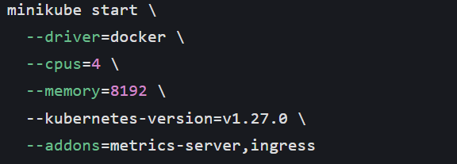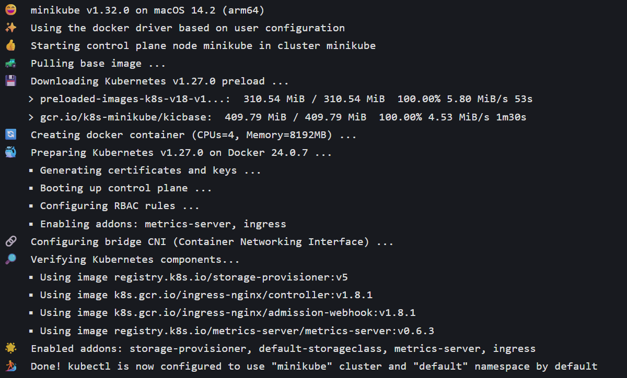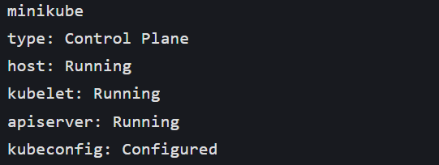Step 2: Install & Configure KServe on Minikube
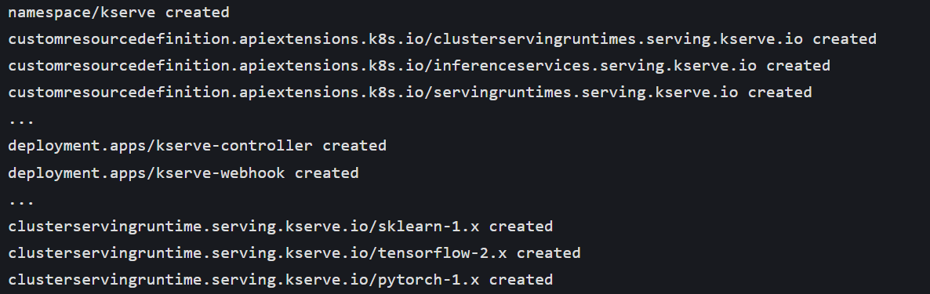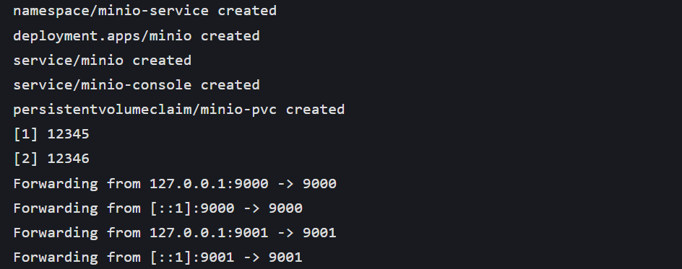Step 3: Prepare a Predictive Model (Iris Classifier)
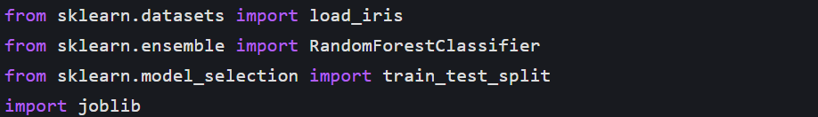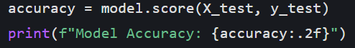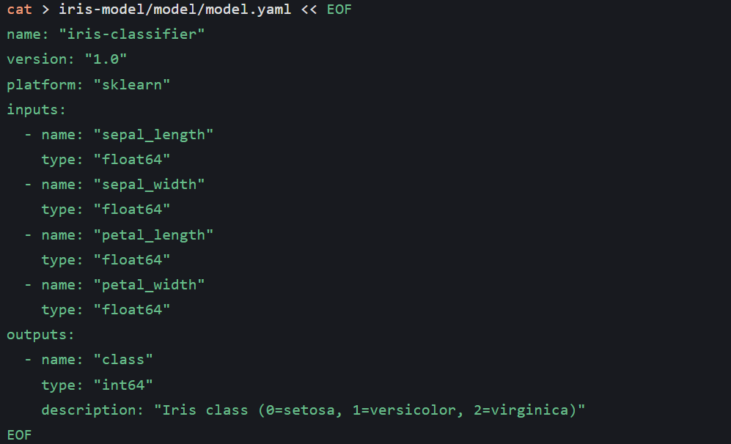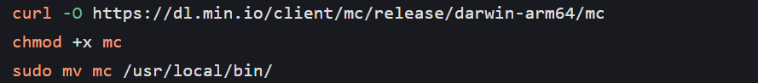Step 4: Deploy Model with KServe InferenceService
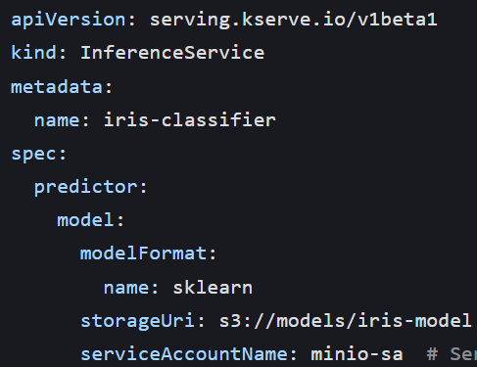Step 5: Monitor Service Status & Debug Common Issues
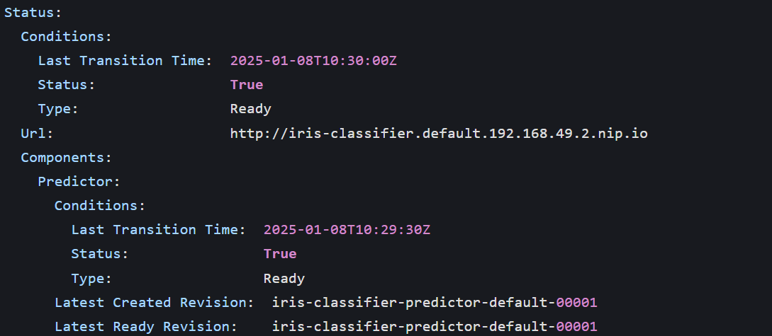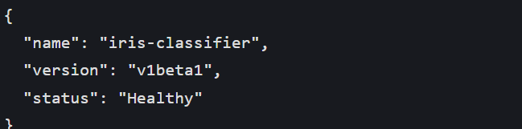Step 7: Send Inference Requests & Interpret Results
